**ST. LAWRENCE COLLEGE**

**COMPUTER PROJECT**



**SUBMITTED BY:**   **SUBMITTED TO:**

NAME: SRIJANA SHRESTHA

GRADE:12

SECTION: A MR. RAJARAM THAPA

FACULTY: SCIENCE (COMPUTER INSTRUCTURE)

For the Partial Fulfilment of the Requirement for Grade 12Computer Science Course Designed By NEB.

**ACKNOWLEDGEMENT**

I would like to express my special thanks and gratitude to my Computer Science teacher ‘Mr. Rajaram Thapa’ who gave me the golden opportunity to do this wonderful project on topic of C Programming which helped me a lot in my studies.

Secondly, I would like to thank my guardians and friends who helped a lot in finalizing the project within the limited time frame. Internet, google and different websites helped me a lot in this project.

**OBJECTIVE**

The objectives of the report are:

* To develop the C program
* To read and display programs by using various methods like loop, array, string, etc.
* To enable sophisticated object-oriented programming
* To enable the complete knowledge about c language

**CONTENTS**

* Introduction to C Programming
* Advantages and Disadvantages of C Programming
* Compiler
* Lab 1 project (Sequence)
* Lab 2 Project (Conditional)
* Lab 3 Project (Loop)
* Lab 4 Project (Array)
* Lab 5 Project (String)
* Introduction to Function
* Lab 6 Project (Function)
* Lab 7 Project (Structure and Union)
* Introduction to Structure and Union
* Lab 8 Project (Pointer)
* Lab 9 Project (File handling)

**Introduction to C Programming**

C is a structured programming language developed by Dennis Ritche. C language is neither a high-level language nor a low-level language. It is very close to machine architecture but independent of it and at the same time does not compromise its ease of use. It is a structured Programming language which is used to develop operating system, business system word processing database management system etc. C seems a strange name for programming language. But this strange sounding language is one of the most popular languages today. ‘C’ was an offspring of the “Basic Combined Programming Language (BCLP) called ‘B’, developed in the 1960’s at Cambridge University.

**Advantages of C Programming**

* It is structured language with functional flow control construct.
* It has high degree of language mobility.
* It is fast and efficient.
* There is no limitation while programming using C.
* C is a powerful language and use of pointer has made it unique.
* It is simple, versatile, portable, and more expensive generalpurpose language. It is more user friendly as compared to previous language.
* It is closely related to lowerlevel language such as assembly level language. It is easy write assembly code in C.
* It is easy for debugging, testing and maintaining.
* Its compiler is easily available.

**Disadvantages of C Programming**

* There is no runtime checking in C language, as the programs extends it is very difficult to fix the bugs.
* C does not have the concept of constructor and destructor.
* It does not have the concept of data hiding, inheritance and polymorphism.
* There are no enough library functions for handling today’s programming environment.
* It is case sensitive so, mixing case makes difficult while programming and to run in latest operating system.

**Compiler**

The main purpose of compiler is to transform a program written in high level programming language from source code into object code. Programmers in a form called source code. Source code must go through several steps before it becomes as executable program.

The first step is to pass the source code through a compiler, which translates the high-level language instructions into object code. The final step in producing an executable program, after the compiler has produced object code, is to pass the object code through a linker. The linker combines modules and gives real values to all symbolic address. All programming languages have their own compiler.

In effect, the compiler is the translator that translates the source code written in programming language into machines code at once.

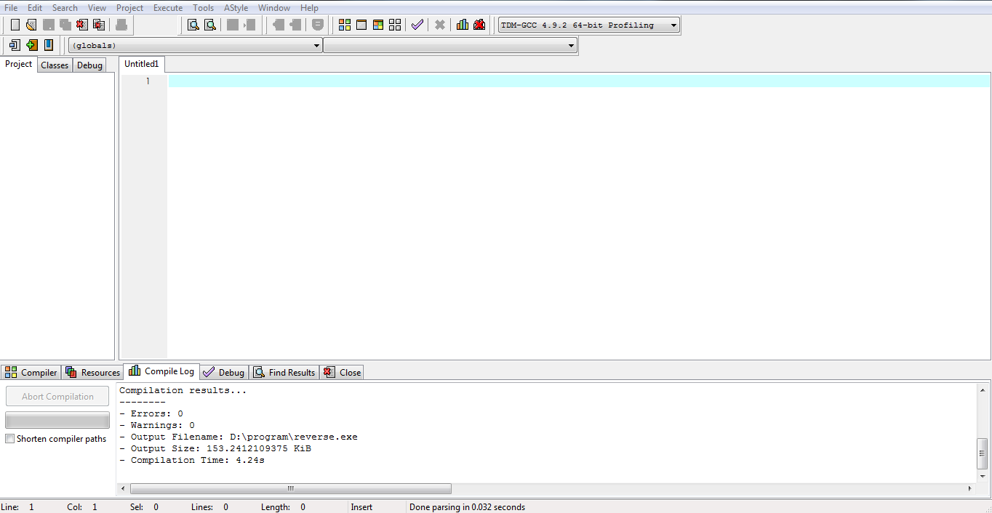

 **ST. LAWRENCE COLLEGE**



***LAB 1: SEQUENCE***

**SUBMITTED BY:**   **SUBMITTED TO:**

NAME: SRIJANA SHRESTHA

GRADE:12

SECTION: A MR. RAJARAM THAPA

FACULTY: SCIENCE (COMPUTER INSTRUCTURE)

For the Partial Fulfilment of the Requirement for Grade 12Computer Science Course Designed By NEB

**Program No:1**

**Title:** WAP to read principle, rate, and number of years and find simple interest and amount.

**Source Code:**//A program to find Simple interest, Amount

#include<stdio.h>

#include<conio.h>

void main ()

{

int p, t ,r, si, a;

printf("enter the principle\n");

scanf("%d",&p);

printf("enter the time\n");

scanf("%d",&t);

printf("enter the rate of interest\n");

scanf("%d",&r);

si=(p*t*r)/100;

a=si+p;

printf("simple interest=%d,amount=%d",si,a);

getch ();}

**OUTPUT:**

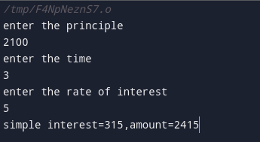

**Program No:2**

**Title:** WAP to Check whether the entered number is prime or composite

**Source Code:**//A program to find number either prime or composite.

#include<stdio.h>

#include<conio.h>

void main ()

{

int i, n,count=0;

printf("enter a number to check whether it is prime or composite ");

scanf("%d",&n);

for (i=1;i<=n;i++)

{

if(n%i==0)

count++;

}

if(count==2)

printf("prime number ");

else

printf("composite number ");

getch ();}

**OUTPUT:**

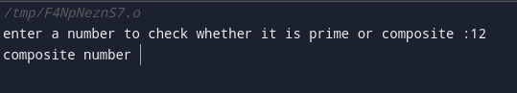

 **ST. LAWRENCE COLLEGE**



***LAB 2: CONDITIONAL***

**SUBMITTED BY:**   **SUBMITTED TO:**

NAME: SRIJANA SHRESTHA

GRADE:12“A”

SECTION: A MR. RAJARAM THAPA

FACULTY: SCIENCE (COMPUTER INSTRUCTURE)

For the Partial Fulfilment of the Requirement for Grade 12Computer Science Course Designed By NEB

**Program No:3**

**Title:** WAP to find the commission amount on the basis of sales amount as per the following conditions.

Sales amount ( Rs.) Commission

0-1000 5%

1001-2000 10%

>2000 12%

**Source Code:**//A program to find commission amount.

#include<stdio.h>

#include<conio.h>

void main()

{

int sales,com;

printf("enter the sales amount");

scanf("%d",&sales);

if(sales>0 && sales<=1000)

{

com=0.05*sales;

printf("commision=%d",com);

}

if(sales>1000 && sales<=2000)

{

com=0.1*sales;

printf("commision=%d",com);

}

if(sales>2000)

{

com=0.12*sales;

printf("commision=%d",com);

}

getch();

}

**OUTPUT:**

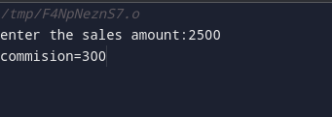

**Program no. :4**

**Title:** WAP to perform arithmetic operation on integer’s data using switch statement. For example: when pressing ‘+’ program should perform addition.

**Source code: \\** a program to perform ‘+’ operation using switch

#include <stdio.h>

#include<conio.h>

void main()

{

char op;

int a,b;

printf("Enter an arthmetic operator (+, -, *, /): ");

scanf("%c", &op);

printf("Enter the values of a and b ");

scanf("%d %d", &a, &b);

switch (op)

{

case '+':

printf("%d + %d = %d", a, b, a + b);

break;

case '-':

printf("%d - %d = %d",a, b, a - b);

break;

case '*':

printf("%d * %d = %d", a, b, a * b);

break;

case '/':

printf("%d / %d = %d", a, b, a / b);

break;

default:

printf("Error! ");

}

getch();

}

**OUTPUT:**

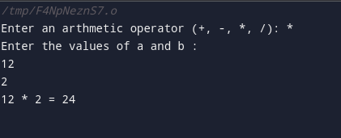

 **ST. LAWRENCE COLLEGE**



***LAB 3: LOOP***

**SUBMITTED BY:**   **SUBMITTED TO:**

NAME: SRIJANA SHRESTHA

GRADE:12

SECTION: A MR. RAJARAM THAPA

FACULTY: SCIENCE (COMPUTER INSTRUCTURE)

For the Partial Fulfilment of the Requirement for Grade 12Computer Science Course Designed By NEB

**Program no.: 5**

**Title:** WAP to find the sum of first N natural numbers.

**Source code:**\\a program to find sum of first n natural number.

#include<stdio.h>

#include<conio.h>

void main()

{

int i,sum=0,n;

printf("enter a number");

scanf("%d",&n);

for(i=1;i<=n;i++)

{

sum=sum+i;

}

printf("total sum= %d",sum);

getch();

}

**OUTPUT:**

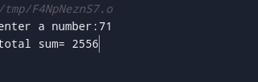

**Program no.: 6**

**Title:** WAP to print all the prime numbers up to hundred.

**Source code:**\\a program to find prime number.

#include <stdio.h>

int main()

{

int i, Number, count;

printf(" Prime Number from 1 to 100 are: \n");

for(Number = 1; Number <= 100; Number++)

{c

ount = 0;

for (i = 2; i <= Number/2; i++)

{

if(Number%i == 0)

{

count++;

break;

} }

if (count == 0 && Number! = 1)

{

printf(" %d ", Number); }}

getch();

}

Output:

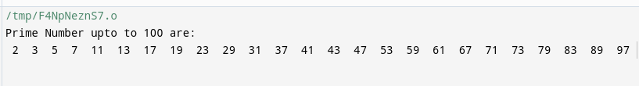

 **ST. LAWRENCE COLLEGE**



***LAB 4: ARRAY***

**SUBMITTED BY:**   **SUBMITTED TO:**

NAME: SRIJANA SHRESTHA

GRADE:12

SECTION: A MR. RAJARAM THAPA

FACULTY: SCIENCE (COMPUTER INSTRUCTURE)

For the Partial Fulfilment of the Requirement for Grade 12Computer Science Course Designed By NEB

**Program no.: 7**

**Title:** WAP to read the salary of N number of employees and count the number of employees getting salary between 10000 to 40000.

**Source code:**\\a program to read salary of n number of employee.

#include<stdio.h>

#include<conio.h>

void main()

{

int i,count=0,salary[100],n;

printf("how many employees?");

scanf("%d",&n);

for(i=0;i<n;i++)

{

printf("enter the salary of employee");

scanf("%d",&salary[i]);

}

for(i=0;i<n;i++)

{

if(salary[i]>=10000 && salary[i]<=40000)

count++;

}

printf("number of employees having salary between 10000 and 40000 is %d",count);

getch();

}

**OUTPUT:**

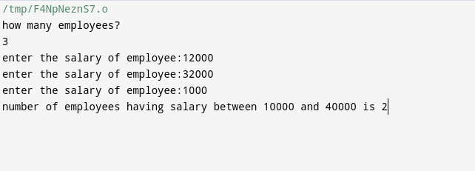

**Program no.: 8**

**Title:** WAP to find the sum of two matrices.

**Source code**:\\a program to find sum of two matrices.

#include<stdio.h>

#include<conio.h>

void main()

{

int A[3][3],B[3][3],C[3][3],i,j;

printf("enter the elements for matrix A\n");

for(i=0;i<3;i++)

{

for(j=0;j<3;j++)

{

printf("enter a[%d][%d]:",i,j);

scanf("%d",&A[i][j]);

}}

printf("enter the elements for matrix B\n");

for(i=0;i<3;i++)

{

for(j=0;j<3;j++)

{

printf("enter b[%d][%d]:",i,j);

scanf("%d",&B[i][j]);

}}

for(i=0;i<3;i++)

{

for(j=0;j<3;j++)

{

C[i][j]=A[i][j]+B[i][j];

}}

printf("\n After addition the new matrix is\n");

for(i=0;i<3;i++)

{

for(j=0;j<3;j++)

{

printf("%d\t",C[i][j]);}

printf("\n");}

getch();

}

**OUTPUT:**

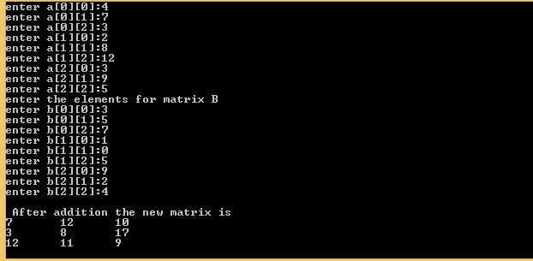

**Program no.: 9**

**Title: WAP to find the transpose of a matrix.**

**Source code:**\\a program to find transpose of matrix.

#include<stdio.h>

int main( )

{

int i,j,n,a[3][3], b[3][3];

for(i=0; i<3; i++)

{

for (j=0; j<3; ++)

{

printf("a%d%d=", i+1, j+1);

scanf("%d",&a[i][j]);}

printf("\n");}

printf("The Transpose of given matrix is \n");

for (i=0; i<3; i++)

{for (j=0; j<3; j++)

{b[i][j] =a[j][i];

printf("%d",b[i][j]);

printf("\t");}

printf("\n");}

getch();}

Output:

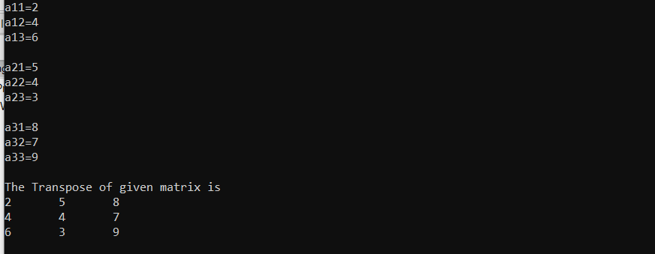

 **ST. LAWRENCE COLLEGE**



***LAB 5: STRING***

**SUBMITTED BY:**   **SUBMITTED TO:**

NAME: SRIJANA SHRESTHA

GRADE:12

SECTION: A MR. RAJARAM THAPA

FACULTY: SCIENCE (COMPUTER INSTRUCTURE)

For the Partial Fulfilment of the Requirement for Grade 12Computer Science Course Designed By NEB

**Program no.: 10**

**Title:** WAP to sort the name of 5 students in Alphabetical order.

**Source code:**\\a program to sort names in alphabetical order.

#include<stdio.h>

#include<string.h>

int main ()

{

int i,j,n;

char str[100][100], s[100];

printf("Enter number of names:\n");

scanf("%d",&n);

printf("Enter names in any order:\n");

for(i=0;i<n;i++)

{

scanf("%s",str[i]);}

for(i=0;i<n;i++)

{

for(j=i+1;j<n;j++)

{

if(strcmp(str[i],str[j])>0)

strcpy(s,str[i]);

strcpy(str[i],str[j]);

strcpy(str[j],s);

} }

}

printf("\nThe sorted order of names are:\n");

for(i=0;i<n;i++);

{

printf("%s\n",str[i]);

getch();

}

**OUTPUT:**

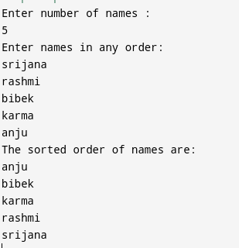

**Program no.: 11**

**Title:** WAP to count numbers of vowels and consonants in a line of text.

**Source code:**\\a program to count numbers of vowel and consonant.

#include <stdio.h>

#include <string.h>

#define MAX_SIZE 100

int main()

{

char str[MAX_SIZE];

int i, len, vowel, consonant;

printf("Enter any string: ");

gets(str);

vowel = 0;

consonant = 0;

len = strlen(str);

for(i=0; i<len; i++)

{

if((str[i]>='a' && str[i]<='z') || (str[i]>='A' && str[i]<='Z'))

{

if(str[i] =='a' || str[i]=='e' || str[i]=='i' || str[i]=='o' || str[i]=='u' ||

str[i] =='A' || str[i]=='E' || str[i]=='I' || str[i]=='O' || str[i]=='U' )

vowel++;

else

consonant++;

}

}

printf("Total number of vowel = %d\n", vowel);

printf("Total number of consonant = %d\n", consonant);

return 0;

}

**OUTPUT:**

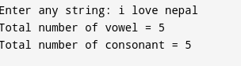

**CONCLUSION**

To sum up, this report helps me to know about C programming language and various types of data types. It helps to develop the simple programs using loop, switch case, array, string, etc.

As I was doing this report, various problem arises that grammatical error, logic error, syntax error. To develop program through C, ones should be careful about small mistakes.

The outcome of the project is that I can easily develop, read, print any type of simple programs. It helps to know about C program.

 **ST. LAWRENCE COLLEGE**



***LAB 6: FUNCTION***

**SUBMITTED BY:**   **SUBMITTED TO:**

NAME: SRIJANA SHRESTHA

GRADE:12

SECTION: A MR. RAJARAM THAPA

FACULTY: SCIENCE (COMPUTER INSTRUCTURE)

For the Partial Fulfilment of the Requirement for Grade 12Computer Science Course Designed By NEB

**Introduction to Function**

A function is a self contained block of statements that performs a particular task or job. It is a logical unit composed of a number of statements grouped into a single unit. Function groups a number of modules of program statements into a unit and gives it a name. A function is a group of statements that together perform a task. Every C program has at least one function, which is main (), and all the most trivial programs can define additional functions.

A function declaration tells the compiler about a function's name, return type, and parameters. A function definition provides the actual body of the function. A function can also be referred as a method or a sub-routine or a procedure, etc. A function definition in C programming consists of a function header and a function body. Here are all the parts of a function:

**Return**  **Type** − A function may return a value. The **return_type** is the data type of the value the function returns. Some functions perform the desired operations without returning a value. In this case, the return type is the keyword **void**.

**Function**  **Name** − This is the actual name of the function. The function name and the parameter list together constitute the function signature.

**Parameters** − A parameter is like a placeholder. When a function is invoked, you pass a value to the parameter. This value is referred to as actual parameter or argument. The parameter list refers to the type, order, and number of the parameters of a function. Parameters are optional; that is, a function may contain no parameters.

**Function**  **Body** − The function body contains a collection of statements that define what the function does.

**Program no.: 12**

**Title:** WAP to find the Area and circumference of a circle.

**Source code:**\\a program to find area and circumference of a circle.

#include<stdio.h>

int circle(int);

int main()

{

int r;

printf("Enter Radius Value of Circle: ");

scanf("%d", &r);

circle(r);

return 0;}

int circle( int r)

{

float circumf,areaf;

circumf=2*3.14*r;

printf(" circumference of circle=%f",circumf);

areaf=3.14*r*r;

printf(" area of circle=%f",areaf);}

getch();}

Output:

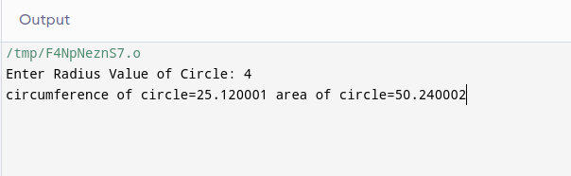

**Program no.: 13**

**Title:** WAP to find the largest and smallest among 10 numbers entered by the user.

**Source code:**\\a program to find largest and smallest number

#include<stdio.h>

#include<conio.h>

void greatest();

void main()

{

greatest();

getch();

}

void greatest ()

{

int a[10],I,greatest,smallest;

printf(“enter 10 numbers”);

for(i=0;i<10;i++)

{

scanf(“%d”,&a[i]);

}

greatest=a[0];

for(i=0;i<10;i++)

{ if(a[i]>greatest)

{ geatest=a[i];

} }

printf(“the greatest number is %d”,greatest);

smallest=a[0];

for(i=0;i<10;i++)

{

if(a[i]<smallest)

{

smallest=a[i];

} }

printf(“the smallest number is %d”,smallest);

}

**OUTPUT:**

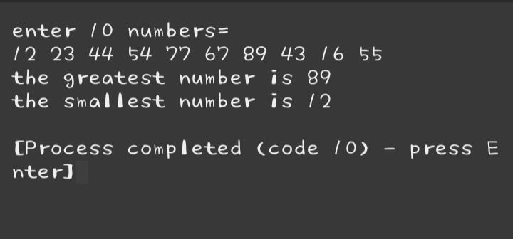

**Program no.: 14**

**Title:** WAP to find if entered number is palindrome or not.

**Source code:**\\a program to find wheatherv number is palindrome or not.

#include<stdio.h>

int checkPalindrome(int number)

{

int temp, remainder, rev=0;

temp = number;

while( number!=0 )

{

remainder = number % 10;

rev = rev*10 + remainder;

number /= 10;}

if ( rev == temp ) return 0;

else return 1;

}

int main()

{

int number;

printf("Enter the number: ");

scanf("%d", &number);

if(checkPalindrome(number) == 0)

printf("%d is a palindrome number.\n",number);

else

printf("%d is not a palindrome number.\n",number);

return 0;

}

**OUTPUT**

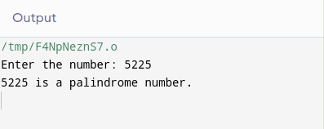

**Program no.: 15**

**Title:** WAP to input the number and reverse irt.

**Source code:**\\a program to find reverse number using function

#include<stdio.h>

int Reverse(int n)

{int sum=0;

while (n!=0)

{

sum = sum*10 + n%10;

n /= 10; }

return sum;}

int main()

{

int number, reverse;

printf("Enter a positive interger: ");

scanf("%d", &number);

reverse = findReverse(number);

printf("The reverse of %d is: %d", number, reverse);

return 0;}

**OUTPUT:**

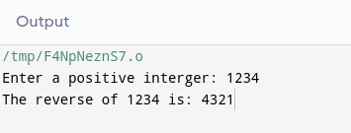

**Program no.: 16**

**Title:** WAP to find Factorial using recursive function.

**source code:**\\a program to find factorial using recursive function

#include<stdio.h>

long fact (int);

int main()

{

int a;

printf( "\n enter number ;");

scanf("%d", &a);

printf(" the factorialof %d number is %ld",a,fact(a));

return(0);}

long fact (int n)

{

if (n==0)

return 1;

else

return ( n* fact (n-1));}

**OUTPUT:**

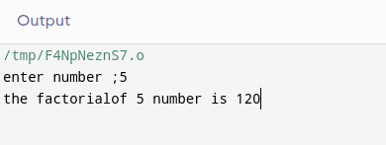

**CONCLUSION**

To sum up, this report helps me to know about C programming language using function. It helps to develop the simple programs using function.

As I was doing this report, various problem arises that grammatical error, logic error, syntax error. To develop program through C, ones should be careful about small mistakes.

The outcome of the project is that I can easily develop, read, print any type of simple programs. It helps to know about C program using function.

 **ST. LAWRENCE COLLEGE**



***LAB 7: STRUCTURE AND UNION***

**SUBMITTED BY:**   **SUBMITTED TO:**

NAME: SRIJANA SHRESTHA

GRADE:12

SECTION: A MR. RAJARAM THAPA

FACULTY: SCIENCE (COMPUTER INSTRUCTURE)

For the Partial Fulfilment of the Requirement for Grade 12Computer Science Course Designed By NEB

**Introduction to Structure and Union**

Structure is a group of variables of different data types represented by a single name. Structure is a user-defined datatype in C language which allows us to combine data of different types together. Structure helps to construct a complex data type which is more meaningful. It is somewhat similar to an Array, but an array holds data of similar type only. But structure on the other hand, can store data of any type, which is practical more useful. Struct keyword is used to define a structure. Struct defines a new data type which is a collection of primary and derived data types. A structure contains an ordered group of data objects. Unlike the elements of an array, the data objects within a structure can have varied data types. Each data object in a structure is a member or field.

A *u*nionis an object similar to a structure except that all of its members start at the same location in memory. A union variable can represent the value of only one of its members at a time. A union is a special data type available in C that allows storing different data types in the same memory location. You can define a union with many members, but only one member can contain a value at any given time. Unions provide an efficient way of using the same memory location for multiple purposes. A union member cannot be a class object that has a constructor, destructor, or overloaded copy assignment operator, nor can it be of reference type. A union member cannot be declared with the keyword static.

A structure or a union can be passed by value to functions and returned by value by functions. The argument must have the same type as the function parameter. A structure or union is passed by value just like a scalar variable as a corresponding parameter.

**Program no.: 17**

**Title:** WAP to Read Name, Address, age and salary of N number of employee and find the average salary.

**source code:**\\a program to find average salary of employeeb using structure.

# include<stdio.h>

#include<conio.h>

void main()

{

Struct employee

{

char name[20];

char address[40];

int age;

float salary;

};

struct employee e[100];

int n,I;

float avg_sal=0;

printf(“how many employees?”);

scanf(“%d”,&n);

for(i=0;i<n;i++)

{

printf(“\nenter the name of employee:”);

scanf(“%s”,&e[i].name);

printf(“enter the address of the employee:”);

scanf(“%s”,&e[i].address);

printf(“enter the age of the employee:”);

scanf(“%d”,&e[i].age);

printf(“enter the salary f the employee:”);

scanf(“%f”,&e[i].salary);

}

for(i=0;i<n;i++)

printf(“name=%s \n address=%s \n age=%d \n salary=%f”,e[i].name,e[i].address,e[i].age,e[i].salary);

Avg_sal=avg_sal+e[i].salary;

Avg_sal=avg_sal/n;

printf(“\n the average salary=%f”,avg_sal);

getch();

}

**OUTPUT:**

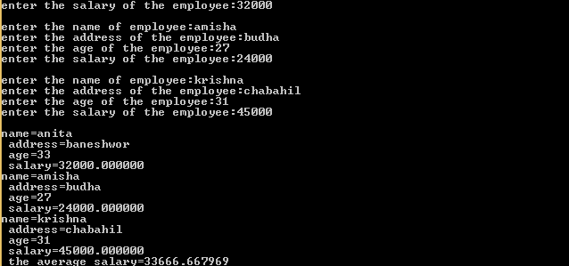

**Program no:18**

**Title:** WAP to store the record of N customer in a bank with fields account number, name and balance and display the records of the customer who has the highest balance in the bank.

**source code:**\\a program to display the highest bank balance among customers

#include<stdio.h>

#include<conio.h>

void main()

{

struct account

{

int acct_no;

char name[40];

float balance;

};

struct account a[100];

int n,i,max_index;

float max_balance;

printf("how many number of customers?");

scanf("%d",&n);

for(i=0;i<n;i++)

{

printf("enter the data for customer");

printf("\nenter the account number:");

scanf("%d",&a[i].acct_no);

. printf("enter the name of the customer:");

scanf("%s",&a[i].name);

printf("enter the balance:");

scanf("%f",&a[i].balance);

}

max_balance=a[0].balance;

max_index=0;

for(i=0;i<n;i++)

{

if(a[i].balance>max_balance)

{

max_balance=a[i].balance;

max_index=i;

}

}

printf("The customer having highest balance is:\n");

printf("name:%s \t account number:%d \t balance:%f",a[max_index].name,a[max_index].acct_no,a[max_index].balance);

getch();

}

**OUTPUT:**

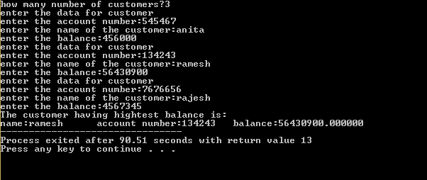

**Program no:19**

**Title:** WAP to read roll number, name and marks of six subjects and display the result with percentage and grade ( prepare grade sheet of one student).

**Source code: A** program to display the result of students with percentage and grade.

#include<stdio.h>

#include<conio.h>

void main()

{

struct student

{

char name[30];

int roll_no;

float marks[6];

};

struct student s;

int i,j;

float total=0,per;

{

printf("enter the data of student\n");

printf("enter the name of student:");

scanf("%s",&s.name);

printf("enter the roll number of student:");

scanf("%d",&s.roll_no);

printf("enter the marks of student in 6 subjects");

for(i=0;i<6;i++)

{

scanf("%f",&s.marks[i]);

}

for(i=0;i<6;i++)

{

total=total+s.marks[i];

}

**OUTPUT:**

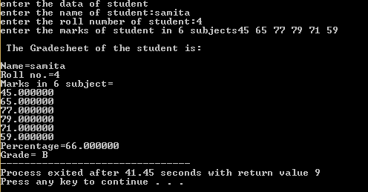

**CONCLUSION**

To sum up, this report helps me to know about C programming language using function. It helps to develop the simple programs using STRUCTURE AND UNION

As I was doing this report, various problem arises that grammatical error, logic error, syntax error. To develop program through C, ones should be careful about small mistakes.

The outcome of the project is that I can easily develop, read, print any type of simple programs. It helps to know about C program using structure.

 **ST. LAWRENCE COLLEGE**



***LAB 8: POINTER***

**SUBMITTED BY:**   **SUBMITTED TO:**

NAME: SRIJANA SHRESTHA

GRADE:12

SECTION: A MR. RAJARAM THAPA

FACULTY: SCIENCE (COMPUTER INSTRUCTURE)

For the Partial Fulfilment of the Requirement for Grade 12Computer Science Course Designed By NEB

**Program no.: 20**

**Title:** WAP to swap 2 numbers using pointer

**source code:**\\a program to swap two numbers

#include <stdio.h>

int main()

{

int x, y, *a, *b, temp;

printf("Enter the value of x and y\n");

scanf("%d %d", &x, &y);

printf("Before Swapping\n x = %d\ny = %d\n", x, y);

a = &x;

b = &y;

temp = *b;

*b = *a;

*a = temp;

printf("After Swapping\nx = %d\ny = %d\n", x, y);

return 0;

}

**OUTPUT:**

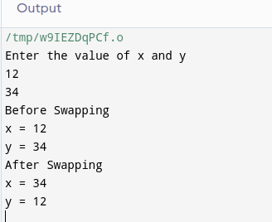

**Program no.: 21**

**Title:**  WAP to sort the n number given by the user

**source code:**\\a program to sort numbers.

#include <stdio.h>

void sort(int n, int* ptr)

{

int i, j, t;

for (i = 0; i < n; i++)

{

for (j = i + 1; j < n; j++) {

if (*(ptr + j) < *(ptr + i)) {

t = *(ptr + i);

*(ptr + i) = *(ptr + j);

*(ptr + j) = t;

}}}

for (i = 0; i < n; i++)

printf("%d ", *(ptr + i));

}

int main()

{

int n = 7;

int arr[] = { 0,4,6,34,2,43,23 };

sort(n, arr);

return 0;

}

**OUTPUT:**

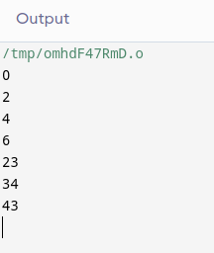

 **ST. LAWRENCE COLLEGE**



***LAB 9: FILE HANDLING***

**SUBMITTED BY:**   **SUBMITTED TO:**

NAME: SRIJANA SHRESTHA

GRADE:12

SECTION: A MR. RAJARAM THAPA

FACULTY: SCIENCE (COMPUTER INSTRUCTURE)

For the Partial Fulfilment of the Requirement for Grade 12Computer Science Course Designed By NEB

**Program no.: 22**

Menu driven WAP which performs the following task

1. Create a data file named Grade12.dat and write record (roll no, name, class, percentage) until n is typed

2. Read all records from the same file and display on the screen in appropriate format

3. Display records of students who have got distinction.

4. Delete delete particular record from the data file on the basis of roll no.( ask the user for the data to be deleted)

#include<stdio.h>

#include<string.h>

void main()

{

int i,j,k,n,roll,per,class,a,b;

char c[5]="y",name[20],s,p;

printf("Enter 'a' to add the details of student\n");

printf("Enter 'r' to display the record\n");

printf("Enter 'p' to display the record of those student who has got distinction\n");

printf("Enter 'd' to delete the record of specific student\n");

scanf("%c",&s);

switch(s)

{

case 'a':

{

FILE *fp;

fp=fopen("record.dat","a");

if(fp==0)

{

printf("The file is not created\n");

}

else

printf("The file is created\n");

do

{

printf("\nName=\t");

scanf("%s",name);

printf("class=\t");

scanf("%d",&class);

printf("roll no=\t");

scanf("%d",&roll);

printf("percentage=\t");

scanf("%d",&per);

fprintf(fp,"%s\t\t%d\t%d\t%d\n",name,class,roll,per);

printf("type y to add \nelse type n \n");

scanf("%s",c);

} while (strcmp(c,"n")!=0);

fclose(fp);

}

break;

case 'r':

{

FILE *fp;

fp=fopen("record.dat","r");

if(fp==0)

{

printf("The file is not created\n");

}

else

printf("The file is created\n");

printf("Name\t\tClass\tRoll\tpercentage\n");

while((p=fgetc(fp))!=EOF)

{

printf("%c",p);

}

fclose(fp);

}

break;

case 'p':

{

FILE *fp;

fp=fopen("record.dat","r");

if(fp==0)

{

printf("The file is not created\n");

}

else

printf("The file is created\n");

printf("\nThe details of student who got distionction are\n");

printf("Name\t\tclass\troll\tpercentage\n");

while((fscanf(fp,"%s%d%d%d",name,&class,&roll,&per))!=EOF)

{

if(per>80)

{

printf("%s\t\t%d\t%d\t%d\n",name,class,roll,per);

}

}

fclose(fp);

}

break;

case 'd':

{

FILE *fp,*gp;

fp=fopen("record.dat","r");

gp=fopen("record1.dat","w");

if(fp==0&&gp==0)

{

printf("The file is not created\n");

}

else

printf("The file is created\n");

int del_roll;

printf("Enter the roll number of student whose details is to be deleted\n");

scanf("%d",&del_roll);

while((fscanf(fp,"%s%d%d%d",name,&class,&roll,&per))!=EOF)

{

if(del_roll!=roll)

{

fprintf(gp,"%s\t\t%d\t%d\t%d\n",name,class,roll,per);

}

}

fclose(fp);

fclose(gp);

FILE *sp,*rp;

sp=fopen("record.dat","w");

rp=fopen("record1.dat","r");

if(rp==0&&sp==0)

{

printf("The deletion is not done\n");

}

else

printf("The deletion is in process...\n");

while((fscanf(rp,"%s%d%d%d",name,&class,&roll,&per))!=EOF)

{

fprintf(sp,"%s\t\t%d\t%d\t%d\n",name,class,roll,per);

}

fclose(sp);

fclose(rp);

}

break;}

}

OUTPUT 1:

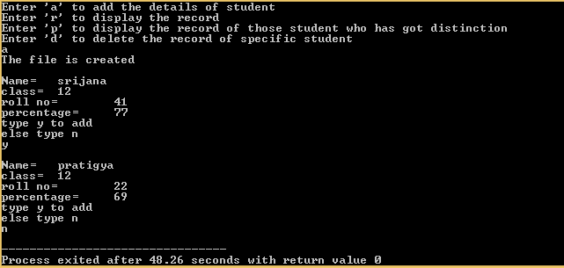

OUTPUT 2:

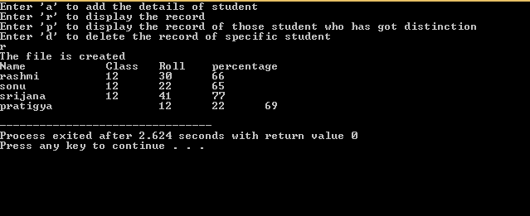

OUTPUT 3:

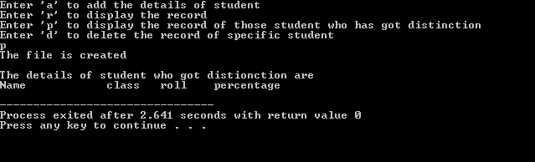

OUTPUT 4:

